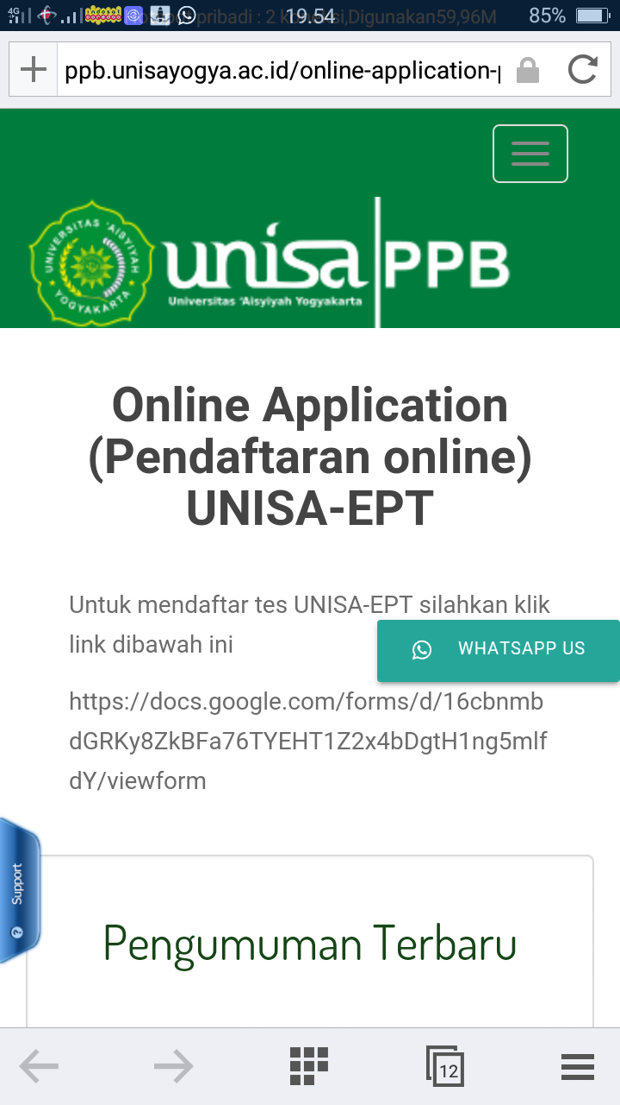

**PENGUMUMAN HASIL UNISA-EPT**

**SABTU, 15 AGUSTUS 2020**

|  |  |  |  |  |  |
| --- | --- | --- | --- | --- | --- |
| **NO** | **NAME** | **PLACE AND DATE OF BIRTH** | **SEX** | **NIM** | **FINAL SCORE** |
| 1 | Nurul Rindhani | Sleman, 09 Februari 1998 | Female | 1610104143 | **320** |
| 2 | Anisa agustin | Kalianda 03 agustus 1998 | Female | 16101014111 | **323** |
| 3 | ANI LATIFAH | TEGAL,25 SEPTEMBER 1977 | Female | 1910104316 | **313** |
| 4 | Sri Suyatmi | Bantul, 8 Desember 1976 | Female | 1910104317 | **350** |
| 5 | RESMY DEWI NURASTIKA | NGAWI/15/02/1990 | Female | 1910104347 | **353** |
| 6 | Muhammad Ariadin | Dompu, 17-07-1998 | Male | 1610601021 | **367** |
| 7 | Evi Diliana Rospia | Tomor-Timor 11 November 1991 | Female | 1810102032 | **647** |
| 8 | Budi Susilawati | Sleman, 18-2-1975 | Female | 1810102002 | **653** |
| 9 | Zuhda Yanti Syafrina | Jambi, 26 Oktober 1994 | Female | 1910104099 | **403** |
| 10 | SUDIYAH | 17 JULI 1972 | Female | 1910104322 | **443** |
| 11 | Fitriyah | Indramayu, 05 September 1998 | Female | 1610201063 | **347** |
| 12 | Trisna oktafiani | Tungku jaya, 22 okt 1997 | Female | 1910104101 | **380** |
| 13 | ANDIKA WAHYUSARI | MAGELANG, 02 APRIL 1979 | Female | 1910104329 | **387** |
| 14 | Rahma Citra | Jakarta, 27 Januari 1997 | Female | 1610105224 | **330** |
| 15 | Anna ayza humaira | Magelang, 08 mei 1996 | Female | 1710105130 | **353** |
| 16 | Hima Athiatus Sa'adah | Sidoarjo, 30 Mei 1995 | Female | 1910104056 | **373** |
| 17 | Indah Retnani | Temanggung, 5 Juni 1985 | Female | 1910104331 | **360** |
| 18 | WINDI AJENG RESPATI | PURWOREJO, 22 DESEMBER 1991 | Female | 1910104055 | **393** |
| 19 | Noviana Saputri | Gunungkidul,08 Agustus 1999 | Female | 1710105279 | **220** |
| 20 | Fadiatul munadiah | Bantaeng 17 oktober 1997 | Female | 1910104028 | **310** |
| 21 | Ela Oktavia | Mulya Kencana, 02 Oktober 1996 | Female | 1810104079 | **343** |
| 22 | Nurul Hikmah | Bima, August 02 2000 | Female | 1710105210 | **463** |
| 23 | Irma Fransiska Claramita | Kediri, 12 Nopember 1995 | Female | 1910104163 | **217** |
| 24 | Siti Zulaekah | Weleri, Kendal, 23 December 1975 | Female | 1910104328 | **303** |
| 25 | Cici dwi oktavianti | Penerokan, 27 juli 1998 | Female | 1610301045 | **330** |
| 26 | Desy Mita Astuti | Bantul, 13 Agustus 1998 | Female | 1610201124 | **390** |
| 27 | Nabila Alpharesi | Serang 09 Agustus 1998 | Female | 1610301087 | **343** |
| 28 | Nanda Dewi Prini | Muara Beliti, 30 April 2000 | Female | 1710105275 | **340** |
| 29 | Yesi Malinda | Lampung barat 07 Mei 1998 | Female | 1610201197 | **393** |
| 30 | Finy Nur Annisafitri | Sari, 25 Agustus 1998 | Female | 1610201030 | **327** |
| 31 | Elena Nabila | Berau, December 1st, 1998 | Female | 1610201018 | **463** |
| 32 | Anggi Dewi Saputri | Pacitan, 23 February 1998 | Female | 1610201026 | **420** |
| 33 | Siti Rohimi Zamzam | Boliyohuto, 16 Mei 1998 | Female | 1610201017 | **337** |
| 34 | Mentary arisca bella | Singkawang, 15 Januari 1998 | Female | 1910104034 | **390** |
| 35 | Niken Purnomo | Gunungkidul 12 Agustus 1997 | Female | 1610201025 | **397** |
| 36 | Elsy Anggie Yutami | Seteluk, 03 September 1999 | Female | 1710505045 | **490** |
| 37 | Arum Nur Hidayah | Sleman, 02 November 2020 | Female | 1610104001 | **350** |
| 38 | Anung Diki Saputra | Bantul, 23 April 1999 | Male | 1710505048 | **377** |
| 39 | NUR AINI RUSTIANA DEWI | BANTUL, 27 JUNE 1998 | Female | 1610201015 | **353** |
| 40 | Lini Karlina | Bungamas, 20 Juli 2000 | Female | 1710105300 | **320** |
| 41 | Fitriatul Ula | Buleleng 19 April 1998 | Female | 1910104157 | **323** |
| 42 | Jamilatun Fajar | Sleman, 7 Juni 1999 | Female | 1610201133 | **343** |
| 43 | Nabilla Widya Meytari | Manna 06-05-1998 | Female | 1610301067 | **353** |
| 44 | Vira Crisa Amanda | Sleman,24 Oktober 2020 | Female | 1610201212 | **387** |
| 45 | Nandyastama Faishal Haqi | Pati, 26 Juni 1997 | Male | 1610301156 | **353** |
| 46 | Syifa Wiji Astuti | Purworejo, 30 Mei 1998 | Female | 1610201085 | **393** |
| 47 | JENNY TIA APRILIA | Ujung Gading, 13 April 1998 | Female | 1610301055 | **543** |
| 48 | Istiqomatud Diniah Achmadah | Situbondo, 20 Juni 1998 | Female | 1910104156 | **387** |
| 49 | Asia Novita | Way Kanan, 05 Juli 1997 | Female | 1610104040 | **333** |
|  | Yustika Zhulfi Putriani | Gunungkidul, 8 April 1998 | Female | 1610201059 | **330** |
|  | Relinda Santri | Sukadana 9 maret 1998 | Female | 1610301172 | **367** |
|  | Nadya Rahmah | Serang, 18 September 1998 | Female | 1910104148 | **340** |
|  | Hasriani | Tomia, 14 November 1999 | Female | 1710505047 | **217** |
|  | Mega pradita wijaya | Sumbawa besar, 14 maret 1998 | Female | 1610301184 | **550** |
|  | Mauliya Widiastuti | Muara Wahau, 08 Juli 1998 | Female | 1610104094 | **350** |
|  | Ari Setiawati | Sri Kencono, 18 Agustus 1998 | Female | 1610104101 | **320** |
|  | Shiva Nabilah | Serang, 28 Maret 1997 | Female | 1610104117 | **233** |
|  | Fatya Nurul Hanifa | Purwokerto, April 29th 1994 | Female | 1810102023 | **217** |
|  | Hairul Syamsudin | 17 Mei 1999 | Male | 1710505065 | **510** |
|  | Astriana windi putri | Prabumulih 19 desember 1998 | Female | 1610301086 | **327** |
|  | Tyas Kurniawati | 23031988 | Female | 1910104314 | **300** |
|  | Helma Virsa Nabilah | 10 Oktober 1998 | Female | 1610301177 | **390** |
|  | Aldi Yulianto Nugroho | Temanggung, 5 Juli 1998 | Male | 1610301234 | **353** |
|  | Devika Aletha | Kab.Semarang, 9 Januari 2020 | Female | 1610301188 | **370** |
|  | Rahma Citra | Jakarta, 27 Januari 1997 | Female | 1610105224 | **330** |
|  | Mawang Wahyuastuti | Bantul, 01-04-1977 | Female | 1910104342 | **307** |
|  | Wahyu hudayana | Pandeglang, 27 Oktober 1997 | Male | 1610301227 | **490** |
|  | Faatika Auliyya Amri | Gunungkidul , 07 juni 1999 | Female | 1610301145 | **357** |
|  | Dyah Resminingsih | Brebes 15 Agustus 1984 | Female | 1910104305 | **343** |
|  | Ninda Purnama Sari | Sleman | Female | 1610201199 | **357** |
|  | LISTYARTI | Wonosobo, 10 Desember 1997 | Female | 1610105203 | **290** |
|  | Salmia Hajar Iskriani | Jakarta, 15 September 1997 | Female | 1610104098 | **487** |
|  | Debby Dama Pertiwi | Sambas, 14 Juli 1997 | Female | 1910104161 | **360** |
|  | Ewit Savitriyanti | Pangkalan Tampoi, 23 Juli 1997 | Female | 1610104062 | **337** |
|  | Ainin Sholekah | Purba Sakti, 13 April 1998 | Female | 1610104074 | **290** |
|  | Liberata Jayanti | Bonet lama, 29 Januari 1986 | Female | 1810102016 | **647** |
|  | Suti Hartati | Bantul, 15 Agustus 1973 | Female | 1910104044 | **337** |

Yogyakarta, 21 Agustus 2020

Kepala Pusat Pengembangan Bahasa



Nor Faizah Kaeni, S.S., M.A.