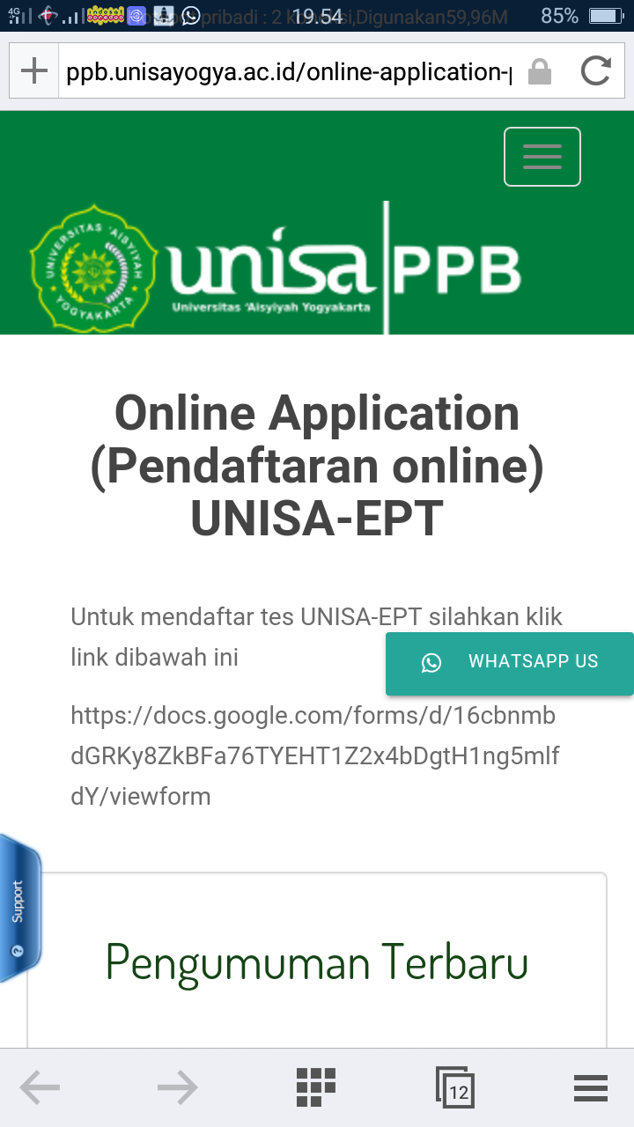

**Daftar Peserta UNISA-EPT Selasa, 15 September 2020**

**Pusat Pengembangan Bahasa Universitas 'Aisyiyah Yogyakarta**

|  |  |  |  |  |  |  |
| --- | --- | --- | --- | --- | --- | --- |
| **No** | **Full Name** | **Student Number** | **Sex** | **Place Of Birth** | **Date Of Birth** | **Study Program** |
| 1 | Rusni Suhaida Wama | 1910104077 | Female | Ambon | 16/08/1990 | Diploma 4 Kebidanan/ Sarjana Terapan Kebidanan |
| 2 | Jumirah | 1910104335 | Female | Banjarmasin | 09/01/1971 | Diploma 4 Kebidanan/ Sarjana Terapan Kebidanan |
| 3 | Dwi Lestari Kurniasih | 1910104326 | Female | Purworejo | 29/01/1972 | Diploma 4 Kebidanan/ Sarjana Terapan Kebidanan |
| 4 | Siti Umroh | 1710105244 | Female | Sumberjo | 26/02/1998 | Diploma 3 Kebidanan |
| 5 | Jumharyati | 1610301211 | Female | Bima | 15/06/1998 | Fisioterapi |
| 6 | Roziana | 1910104136 | Female | Dabo Singkep | 06/05/1997 | Diploma 4 Kebidanan/ Sarjana Terapan Kebidanan |
| 7 | Annisa Lutfy Husnaini | 1610301035 | Female | Rajabasa Lama | 13/09/1998 | Fisioterapi |
| 8 | Sukmawati Ely | 1910104137 | Female | Ureng | 01/06/1997 | Diploma 4 Kebidanan/ Sarjana Terapan Kebidanan |
| 9 | Yuliana Pramesti Wulan Sari | 1610104122 | Female | Semarang | 16/06/1997 | Diploma 4 Kebidanan/ Sarjana Terapan Kebidanan |
| 10 | Dita Hirani | 1610104004 | Female | Baturaja | 11/09/1998 | Diploma 4 Kebidanan/ Sarjana Terapan Kebidanan |
| 11 | Halifa Rumbaty | 1910104047 | Female | Kilmoy | 12/10/1996 | Diploma 4 Kebidanan/ Sarjana Terapan Kebidanan |
| 12 | Diah Ely Permata Sari | 1610104056 | Female | Qurnia Mataram | 10/08/1997 | Diploma 4 Kebidanan/ Sarjana Terapan Kebidanan |
| 13 | Ulfatul Aini | 1610104069 | Female | Kananga | 27/07/1998 | Diploma 4 Kebidanan/ Sarjana Terapan Kebidanan |
| 14 | Mayang Nurma Yesinta | 1610104045 | Female | Temanggung | 18/05/1998 | Diploma 4 Kebidanan/ Sarjana Terapan Kebidanan |
| 15 | Isti Yuli Hidayati | 1610104124 | Female | Rimbo Mulya | 23/07/1998 | Diploma 4 Kebidanan/ Sarjana Terapan Kebidanan |
| 16 | Nuryusri'a Arffa Fais Idris | 1610104145 | Female | Masohi | 08/04/1998 | Diploma 4 Kebidanan/ Sarjana Terapan Kebidanan |
| 17 | Zaitun Vadilah Rumodar | 1610104133 | Female | Jayapura | 08/09/1998 | Diploma 4 Kebidanan/ Sarjana Terapan Kebidanan |
| 18 | Elva Yuliana | 1610201132 | Female | Srikencono | 17/07/1997 | Ilmu Keperawatan |
| 19 | Nurjana Siwasiwan | 1610104131 | Female | Kleser | 23/07/1998 | Diploma 4 Kebidanan/ Sarjana Terapan Kebidanan |
| 20 | Suryati | 1810102074 | Female | Sape | 01/07/1993 | S2 Kebidanan |
| 21 | Octivyan Unpar Arrisqi | 1610104136 | Female | Palngkaraya | 29/10/1998 | Diploma 4 Kebidanan/ Sarjana Terapan Kebidanan |
| 22 | Vina Mulyanti | 1611304092 | Female | Boal 9 September 1998 | 09/09/1998 | Teknologi Laboratorium Medis |
| 23 | Ratriana Uswatun Khasanah | 1611304094 | Female | Sleman | 17/08/1998 | Teknologi Laboratorium Medis |
| 24 | Esty Farida | 1610201068 | Female | Magelang | 15/03/1998 | Ilmu Keperawatan |
| 25 | Sumini Hirdayanti Henaulu | 1610104134 | Female | Ambon | 02/10/1997 | Diploma 4 Kebidanan/ Sarjana Terapan Kebidanan |
| 26 | Defiana Susanti | 1710105187 | Female | Sleman | 11/12/1998 | Diploma 3 Kebidanan |
| 27 | Magfirah Awaliah | 1610801007 | Female | Sangkulirang | 16/02/1998 | Psikologi |
| 28 | Puji Lestari | 1810102082 | Female | Taba Anyar | 10/10/1995 | S2 Kebidanan |
| 29 | Tety Septiani | 1810102070 | Female | Palembang | 06/09/1993 | S2 Kebidanan |
| 30 | Nova Arami | 1810102049 | Female | Takengon | 25/12/1994 | S2 Kebidanan |
| 31 | Yulia Uswatun Hasanah | 1910104134 | Female | Tasikmalaya | 18/07/1997 | Diploma 4 Kebidanan/ Sarjana Terapan Kebidanan |
| 32 | Siti Afni Zulfah | 1910104135 | Female | Indramayu | 28/04/1997 | Diploma 4 Kebidanan/ Sarjana Terapan Kebidanan |
| 33 | Ella Antika | 1610901010 | Female | Way Kanan Lampung | 28/03/1998 | Ilmu Komunikasi |
| 34 | Eva Rahayu | 1710105240 | Female | Kudus | 16/12/1998 | Diploma 3 Kebidanan |
| 35 | Fitri Ramdhani | 1910104130 | Female | Kendari | 03/04/1992 | Diploma 4 Kebidanan/ Sarjana Terapan Kebidanan |
| 36 | Dilla Angeliawati | 1710105186 | Female | Oku Timur | 15/07/1999 | Diploma 3 Kebidanan |
| 37 | Ratri Amaranggani | 1610104128 | Female | Gunungkidul | 17/07/1998 | Diploma 4 Kebidanan/ Sarjana Terapan Kebidanan |
| 38 | Syalviany Muthya | 1610301100 | Female | Banjarmasin | 11/06/1998 | Fisioterapi |
| 39 | Jefri Kurniawan | 1610201076 | Male | Lampung Tengah | 26/05/1998 | Ilmu Keperawatan |
| 40 | Isnaini Putri Amalia | 1610201089 | Female | Depok | 16/11/1998 | Ilmu Keperawatan |