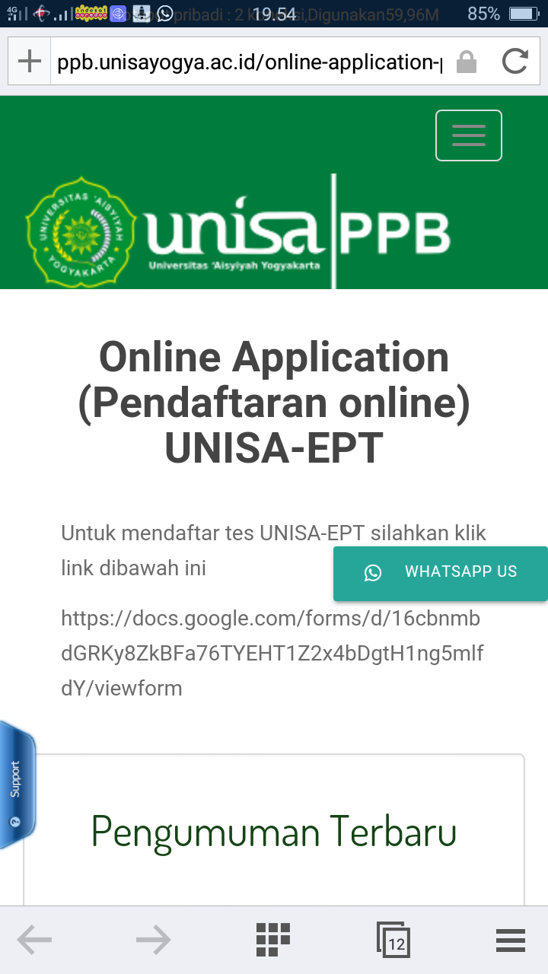

**Daftar Peserta UNISA-EPT Kamis, 17 September 2020**

**Pusat Pengembangan Bahasa Universitas 'Aisyiyah Yogyakarta**

|  |  |  |  |  |  |  |
| --- | --- | --- | --- | --- | --- | --- |
| **No** | **Full Name** | **Student Number** | **Sex** | **Place of Birth** | **Date of Birth** | **Study Program** |
| 1 | Sartika Wulan Anjani | 1710105185 | Female | Kampar | 21/10/1998 | Diploma 3 Kebidanan |
| 2 | Jumharyati | 1610301211 | Female | Bima | 15/06/1998 | Fisioterapi |
| 3 | Fitriyah | 1610201063 | Female | Indramayu | 05/09/1998 | Ilmu Keperawatan |
| 4 | Endang Hijrohwati | 1910104313 | Female | Brebes | 10/10/1969 | Diploma 4 Kebidanan/ Sarjana Terapan Kebidanan |
| 5 | Tania Sri Indah Kusumas Tuti | 1610601008 | Female | Penyombaan | 28/06/1998 | Manajemen |
| 6 | Nur Baiti | 1810105005 | Female | Jangkang 2 | 28/11/1999 | Diploma 3 Kebidanan |
| 7 | Fadiatul Munadiah | 1910104028 | Female | Bantaeng | 17/10/1997 | Diploma 4 Kebidanan/ Sarjana Terapan Kebidanan |
| 8 | Isnaini Ashari | 1610104023 | Female | Ketapang, Kalimantan Barat | 08/09/1997 | Diploma 4 Kebidanan/ Sarjana Terapan Kebidanan |
| 9 | Yustika Zhulfi Putriani | 1610201059 | Female | Gunungkidul | 08/04/1998 | Ilmu Keperawatan |
| 10 | Revina Zakia | 1610701008 | Female | Pekanbaru | 17/08/1998 | Akuntansi |
| 11 | Hayatul Rahimah | 1810102043 | Female | Jombang | 20/01/1988 | S2 Kebidanan |
| 12 | Irvan Kurniawan | 1610201072 | Male | Sleman | 21/01/1996 | Ilmu Keperawatan |
| 13 | Fransiska A.Hadji | 1610104047 | Female | Gorontalo | 10/09/2020 | Diploma 4 Kebidanan/ Sarjana Terapan Kebidanan |
| 14 | Audita Rahmawati | 1610301099 | Female | Sleman | 18/01/1998 | Fisioterapi |
| 15 | Wiwit Laras Subekti | 1610301108 | Female | Kulon Progo | 13/02/1997 | Fisioterapi |
| 16 | Ilmi Oktaviani | 1710105143 | Female | Sleman | 08/10/2020 | Diploma 3 Kebidanan |
| 17 | Ayu Fitriyani | 1610104097 | Female | Seram | 11/02/1998 | Diploma 4 Kebidanan/ Sarjana Terapan Kebidanan |
| 18 | Aprilia Ayu Distia | 1610301131 | Female | Yogyakarta | 08/04/1997 | Fisioterapi |
| 19 | Hayati Nufus | 1610301135 | Female | Serang | 24/10/1997 | Fisioterapi |
| 20 | Najwan Ajie Nugraha | 1610301162 | Male | Barabai | 03/07/1998 | Fisioterapi |
| 21 | Tian Nopiyanti | 1910104172 | Female | Ciamis | 23/11/1997 | Diploma 4 Kebidanan/ Sarjana Terapan Kebidanan |
| 22 | Elza Lorenza | 1710105189 | Female | Martapura | 22/01/2000 | Diploma 3 Kebidanan |
| 23 | Alamsyah Nur Arsyi | 1610301235 | Male | Sleman | 11/12/1994 | Fisioterapi |
| 24 | Tri Utami Handayani | 1610201099 | Female | Kulon Progo | 14/02/1998 | Ilmu Keperawatan |
| 25 | Desi Permata Andrieyana Emaridha | 1610201145 | Female | Blora | 20/12/1998 | Ilmu Keperawatan |