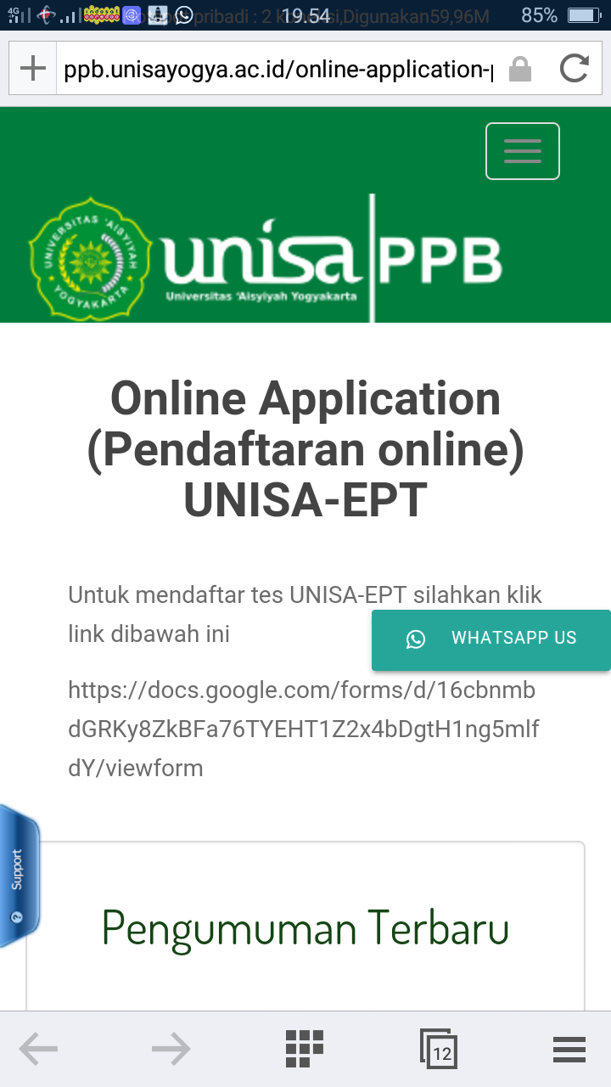

**Daftar Peserta UNISA-EPT Kamis, 3 September 2020**

**Pusat Pengembangan Bahasa Universitas 'Aisyiyah Yogyakarta**

|  |  |  |  |  |  |
| --- | --- | --- | --- | --- | --- |
| **No** | **Name** | **NIM** | **Sex** | **Place and Date of Birth** | **Study Program** |
| 1 | Indah Purnama Sari | 1910104192 | Female | Mendala,19 Desember 1999 | Diploma 4 Kebidanan/ Sarjana Terapan Kebidanan |
| 2 | Alvin Yos Djihanga | 1810102001 | Female | 09 April 1976 | S2 Kebidanan |
| 3 | Nurul Muthi'ahtul Husna | 1610301197 | Female | Bima, 03 Desember 1998 | Fisioterapi |
| 4 | Nurfarhatin Ramdani | 1610301200 | Female | Bima,28 Januari 1998 | Fisioterapi |
| 5 | Nur Hasanah | 1910104122 | Female | 12 Desember 1997 | Diploma 4 Kebidanan/ Sarjana Terapan Kebidanan |
| 6 | Mariska | 1910104104 | Female | Pasir Panjang, 15 April 1998 | Diploma 4 Kebidanan/ Sarjana Terapan Kebidanan |
| 7 | Dwi Susilowati Di Reschejule | 1910104154 | Female | Banyuasin 12 Desember 1995 | Diploma 4 Kebidanan/ Sarjana Terapan Kebidanan |
| 8 | Siti Nurhayati | 1610201128 | Female | 30 November 1997 | Ilmu Keperawatan |
| 9 | Zakiah Aqsa | 1910104007 | Female | Kp. Jeumpa, 28 Februari 1997 | Diploma 4 Kebidanan/ Sarjana Terapan Kebidanan |
| 10 | Elisa Delitasari | 1610104018 | Female | Jatimulyo, 14 November 1997 | Diploma 4 Kebidanan/ Sarjana Terapan Kebidanan |
| 11 | Bagus Afrizam Rizky | 1610301159 | Male | Sleman, 28 June 1998 | Fisioterapi |
| 12 | Muhammad Akbar | 1610301205 | Male | Dompu, 20 April 1998 | Fisioterapi |
| 13 | Nadya Rahmah | 1910104148 | Female | Serang, 18 September 1998 | Diploma 4 Kebidanan/ Sarjana Terapan Kebidanan |
| 14 | Aisyah | 1710105280 | Female | Kulon Progo, 28 Agustus 1998 | Diploma 3 Kebidanan |
| 15 | Listi Hari Muntasih | 1710105198 | Female | Raja Basa Lama, 31-01-1999 | Diploma 3 Kebidanan |
| 16 | Fifin Dyah Lindawati | 1610105262 | Female | Buol 05 Mei 1999 | Diploma 3 Kebidanan |
| 17 | Ida Laila Lutfia | 1710105190 | Female | 08 Januari 1999 | Diploma 3 Kebidanan |
| 18 | Sartika Wulan Anjani | 1710105185 | Female | Kampar, 21 Oktober 1998 | Diploma 3 Kebidanan |
| 19 | Jumharyati | 1610301211 | Female | 15 Juni 1998 | Fisioterapi |
| 20 | Siti Handayani | 1710105182 | Female | 14 Juni 1999 | Diploma 3 Kebidanan |
| 21 | Supiani (Reschedule) | 1810102067 | Female | Mamben Lauk, 17-02-1992 | S2 Kebidanan |
| 22 | Afif Fairuz Fajri A. Zain | 1610301224 | Male | Sukadana, 27 September 1998 | Fisioterapi |
| 23 | Dendi Trapsilo | 1610301196 | Male | Dayamurni 15 September 1998 | Fisioterapi |
| 24 | Imam Rustadi | 1710505057 | Male | Tanah Merah, Lipatkain 23 Agustus 1999 | Diploma 3 Radiologi |
| 25 | Telga Oktriani | 1710505051 | Female | Serasan, 28 Oktober 2020 | Diploma 3 Radiologi |
| 26 | Wahyu Nur Indah Kustiani | 1710105184 | Female | Seputih Banyak, 29 Juni 1998 | Diploma 3 Kebidanan |
| 27 | Aninda Ayu Putri Fuspita Sari | 1910104004 | Female | Sidomukti, 12 Juli 1997 | Diploma 4 Kebidanan/ Sarjana Terapan Kebidanan |
| 28 | Zulkifli | 1610301214 | Male | 04 Mei 1999 | Fisioterapi |
| 29 | Ulfa Khoirun Nisa' | 1910104107 | Female | Pekalongan, 21 Februari 1997 | Diploma 4 Kebidanan/ Sarjana Terapan Kebidanan |
| 30 | Aprilia Ayu Distia | 1610301131 | Female | Yogyakarta, 8 April 1998 | Fisioterapi |
| 31 | Aulia Farhanah | 1610301132 | Female | Sumedang, 7 March 1998 | Fisioterapi |
| 32 | Erria Sukmasari Putri | 1710105251 | Female | 30 Juli 1999 | Diploma 3 Kebidanan |
| 33 | Putri Ratnaningsih | 1610301129 | Female | Sleman, 22 June 1998 | Fisioterapi |
| 34 | Reni | 1710105245 | Female | Lombok Timur, 13 Februari 2020 | Diploma 3 Kebidanan |
| 35 | Asia Novita | 1610104040 | Female | Way Kanan, 05 Juli 1997 | Diploma 4 Kebidanan/ Sarjana Terapan Kebidanan |
| 36 | Yuni Nerawati | 1710105242 | Female | Batumarta Ii, 30 Juli 1999 | Diploma 3 Kebidanan |
| 37 | Ines Nurhafifa Saleh | 1710505078 | Female | Wawonngole 13 Oktober 1998 | Diploma 3 Radiologi |
| 38 | Amelia Eka Yani Salim | 1610301143 | Female | Sukoharjo, 25 Maret 1998 | Fisioterapi |
| 39 | Eko Yulianto | 2,0151e+11 | Male | 14 Juli 1996 | Ilmu Keperawatan |
| 40 | Aisyah Kurnia Putri | 1610104086 | Female | Yogyakarta, 3 Maret 1998 | Diploma 4 Kebidanan/ Sarjana Terapan Kebidanan |
| 41 | Sholihah Gustavia Yolanda | 1610104060 | Female | Bandar Lampung, 14 Agustus 1998 | Diploma 4 Kebidanan/ Sarjana Terapan Kebidanan |
| 42 | Embun Kemuning Senja | 1610301052 | Female | Manna, 15 Januari 1999 | Fisioterapi |
| 43 | Rizqi Amaliya Mega Setyawan | 1610301066 | Female | Tegal, 28 Juni 1998 | Fisioterapi |
| 44 | Silvi Tohirotul Munawaroh | 1710105265 | Female | Brebes,10 Mei 1999 | Diploma 3 Kebidanan |
| 45 | Khulasoh | 1910104017 | Female | Kebumen,16 September 1996 | Diploma 4 Kebidanan/ Sarjana Terapan Kebidanan |
| 46 | Jumratul | 1610301060 | Female | Padolo, 5 Mei 1998 | Fisioterapi |
| 47 | Dian Nuriana | 1710105274 | Female | Gumawang, 08 Juni 1999 | Diploma 3 Kebidanan |
| 48 | Shofiatul Andani | 1710105272 | Female | Pancor, 6 Agustus 1998 | Diploma 3 Kebidanan |
| 49 | Astriana Windi Putri | 1610301086 | Female | Prabumulih, 19 Desember 1998 | Fisioterapi |
| 50 | Ryno Julyan Muladhanna | 1610301206 | Male | Sumbawa, 28 Juli 1998 | Fisioterapi |
| 51 | Venni Ficauly | 1710105278 | Female | Kebur 23 Febuari 2000 | Diploma 3 Kebidanan |
| 52 | Nurrahmi Abdullah | 1710505067 | Female | Ternate 08 Januari 2000 | Diploma 3 Radiologi |
| 53 | Arista Apriani | 1810102048 | Female | Magetan, 30 April 1988 | S2 Kebidanan |
| 54 | Wijayanti | 1810102053 | Female | Karanganyar, 20 Maret 1984 | S2 Kebidanan |
| 55 | Wina Sugianty | 1910104117 | Female | Samboja, 22 Februari 1995 | Diploma 4 Kebidanan/ Sarjana Terapan Kebidanan |
| 56 | Neni Sri Rahayu | 1910104116 | Female | Balikpapan, 10 November 1998 | Diploma 4 Kebidanan/ Sarjana Terapan Kebidanan |
| 57 | Dwi Candra Ambar Wati | 1910104126 | Female | Baturaya, 23 Desember 1998 | Diploma 4 Kebidanan/ Sarjana Terapan Kebidanan |
| 58 | Rafilah Azmi Paputungan | 1610104140 | Female | Sentani, 17 Agustus 1998 | Diploma 4 Kebidanan/ Sarjana Terapan Kebidanan |